ARM ISA

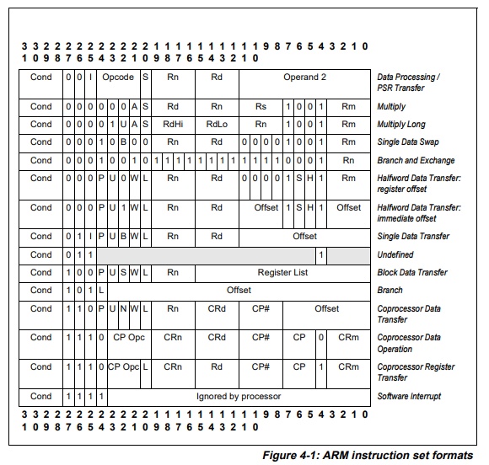

- Arithmetic / Data Processing
  - ADD - Adds two operands and writes result to destination register.
  - SUB - Subtracts second operand from first and writes result.
  - MOV - Copies a value (register or immediate) into a register.
  - CMP - Performs subtraction only to set condition flags, does NOT write result.
  - LSL - Logical shift left (used to multiply index by 4 for array access).
    - Ex - MOV r3, r3, LSL #2 [Mov is used as the instruction for LSL]
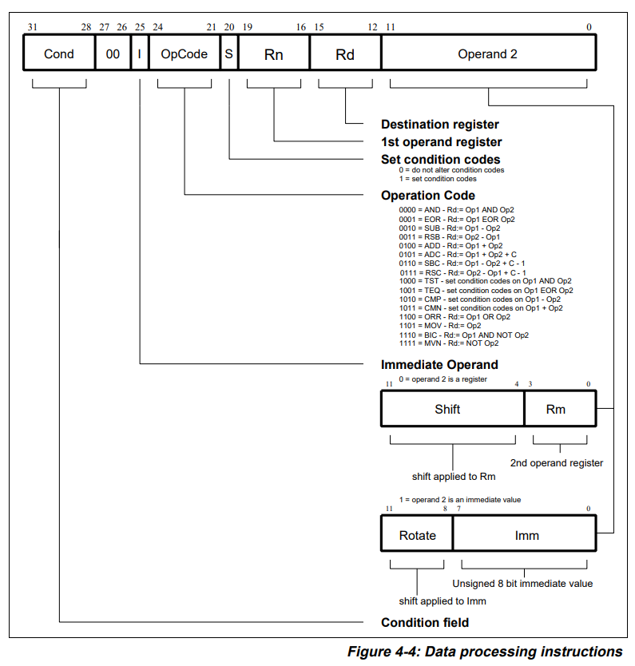
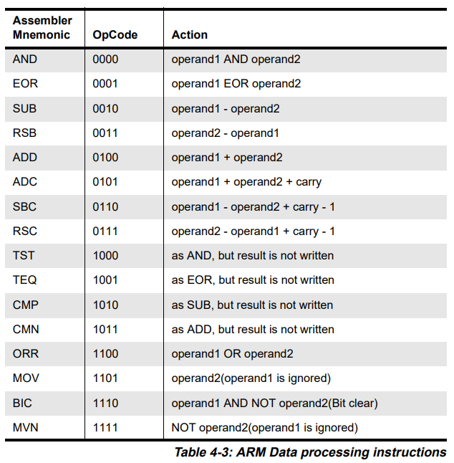
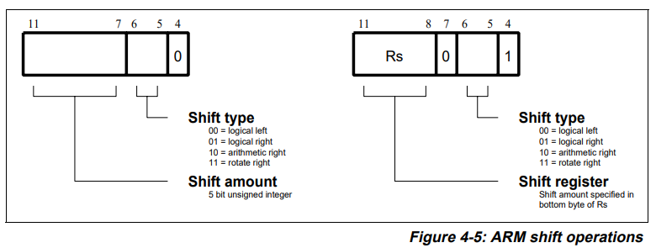
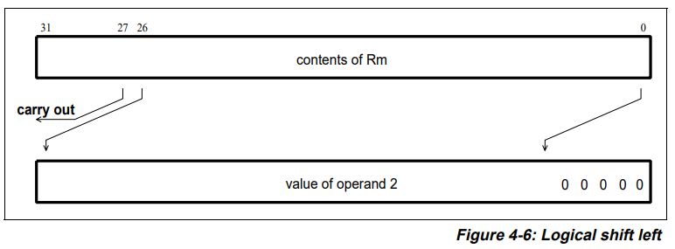

- Memory Access (Single Register)
  - LDR - Loads a 32-bit word from memory into a register.
  - STR - Stores a 32-bit register value into memory.
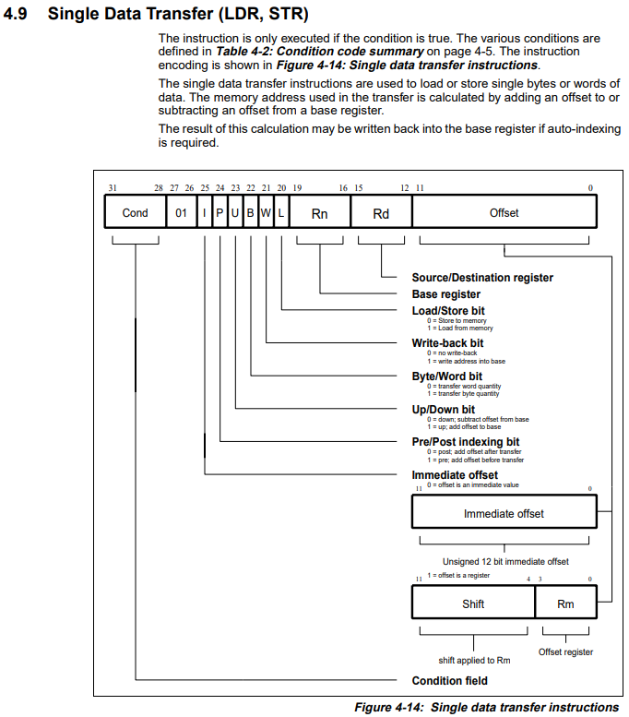
- Memory Access (Multiple Registers)
  - LDM - Load multiple registers from memory starting at base address.
  - STM - Store multiple registers to memory starting at base address.
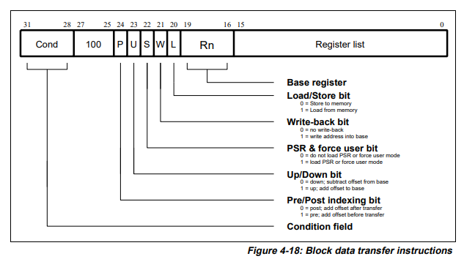
  - LDMIA - Load multiple registers, increment address after each load.
  - STMIA - Store multiple registers, increment address after each store.

- Stack Operations (Aliases)
  - PUSH - Stores multiple registers onto the stack (alias for STMDB).
  - POP - Loads multiple registers from the stack (alias for LDMIA).

- Control Flow
  - B - Unconditional branch to a label.
    - What hardware does:
      - Calculate branch target address
      - Replace PC with that address
      - No flags involved.
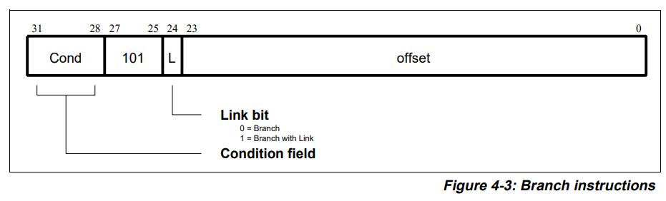
  - BLE - Branch if Less Than or Equal (based on flags).
    - BLE condition = (Z == 1) OR (N != V)
      - Z == 1 : for equal to
      - N != V : No overflow should be there, only then the true MSB is seen so V == 0. True MSB is 1 means its negative that means A<B. (V == 0 is not equal to N == 1)
  - BGE - Branch if Greater Than or Equal (based on flags).
    - BGE condition = (N == V)
      - No overflow but if not negative then it means A>B. (V == 0 is equal to N == 0)
  - BX - Branch to address stored in register (used for return).

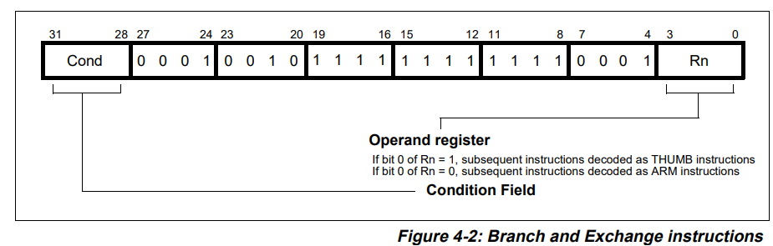
This instruction performs a branch by copying the contents of a general register, Rn, into the program counter, PC
    - Hardware must:
      - Read value of register (lr)
      - Load it into PC
      - No offset.
      - No condition.

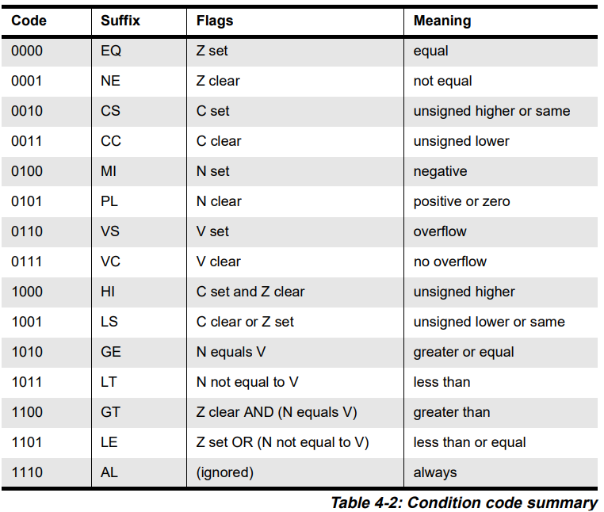

- Special Register Names:
Register | Alias | Meaning
r13 | sp | Stack Pointer
r14 | lr | Link Register
r15 | pc | Program Counter
r11 | fp | Frame Pointer (by convention)

